Crestron HTML UI Design
With the release of the new Crestron 80 series touch panels that no longer support flash programmed user interfaces, I have decided to gather three options for programmers who will be building UIs on these panels soon. With the difficulty and inconsistency that comes with Crestron’s own IDE (Construct), I will present it as one of the options here, but the goal of this document is also to provide two other examples for building touch panel interfaces.
Crestron Construct
Crestron Construct offers a similar experience to VTPro in a graphical style interface, drag and drop methodology, join numbers, and easy to compile to an archive for a touch panel in the form of a .ch5z file. It also adds functions for subscription join naming, new smart graphic extensions, and a host of new button designs and features. It is, however, still difficult to work with and build an easy design. There are also some missing features from VTPro that are eventually added in, such as the recent addition of the media player interface.
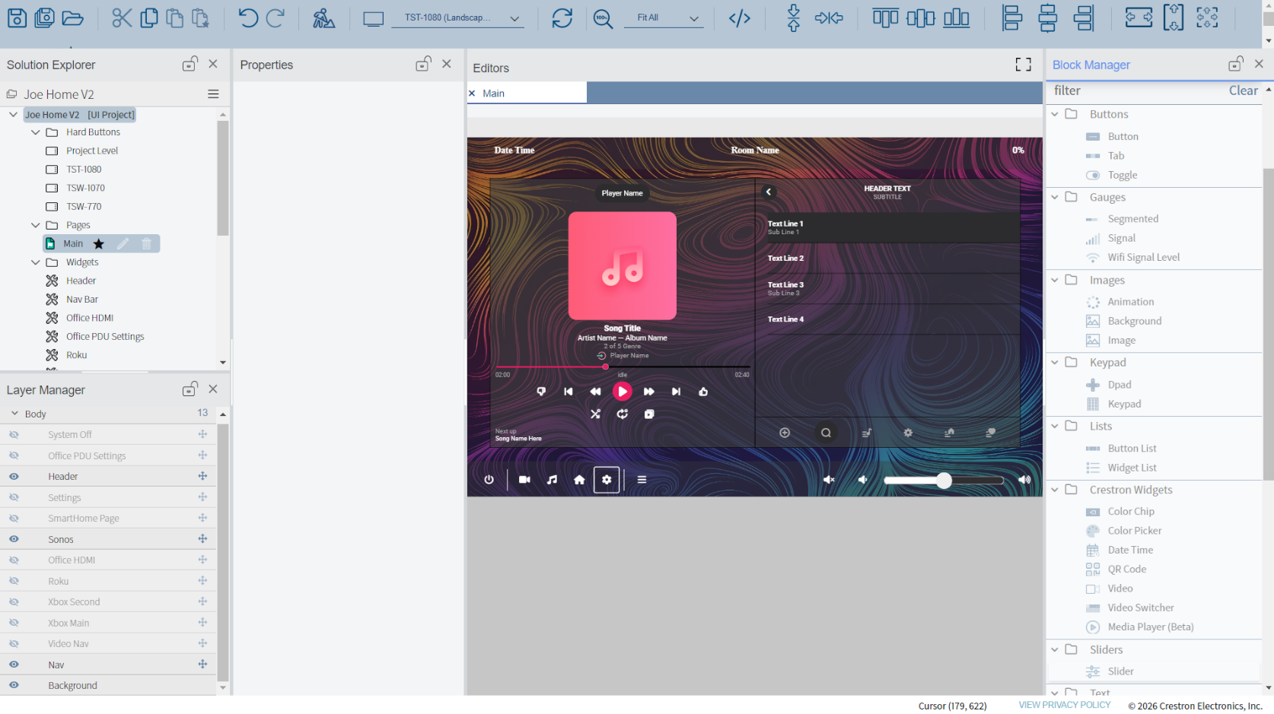

With Construct I have not been able to successfully get media player working just yet as shown in my example above, but it is still a recently added feature. There also comes a new learning curve of items that I have had to dig through such as the use of advanced buttons with multiple style states versus regular buttons.
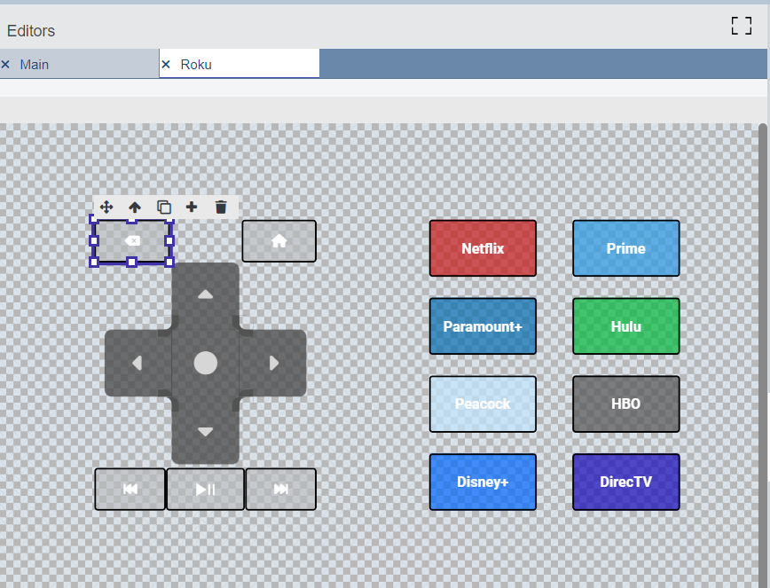

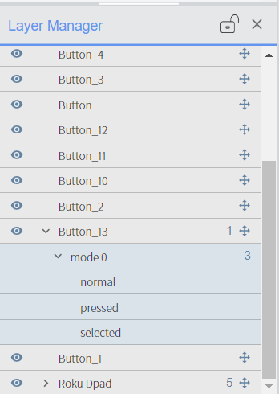
On this page for example, to change a button to advanced button, click the plus icon when highlighting over the button.
This will then provide a dropdown for different button modes.

Although Construct still needs a lot of time to mature regarding features and settings, it is starting to be a real solution for upcoming HTML Crestron panels. I was able to build multiple multi-room projects in Construct myself and got past the learning curve rather quickly.
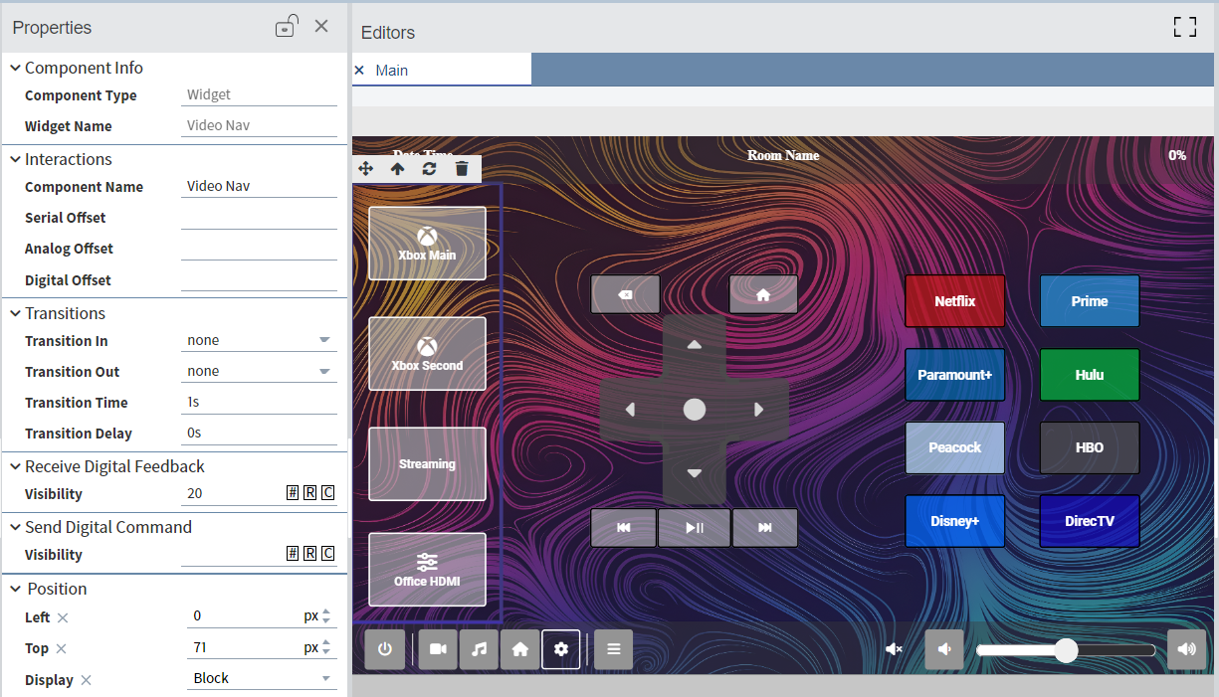

CH5 CrComLib React App
Over the last few days, I've worked with Claude Code to build out an HTML React app using TypeScript and the Crestron Communication Library (CrComLib) for signal joins and subscribed states. React handles the UI — the buttons, sliders, and status indicators the user interacts with — while CrComLib handles communication with the processor, publishing joins when the UI is touched and updating the UI when joins change on the processor side. In this React app, I have built a components library for programmers to use on their own UIs and will go over it in short detail as well, since all in-depth instructions are in the README file. I've also built out an example CP3 SIMPL program to demonstrate the subscribed states, which I'll go over below.
To start, we have our code folder that can be opened in most IDEs, such as my choice with Visual Studio Code. Before running the project, make sure Node.js is installed on your machine — this is a one-time setup step. From there, the code folder includes a README with the exact commands and instructions to install dependencies and launch the app, so you won't need to memorize anything.
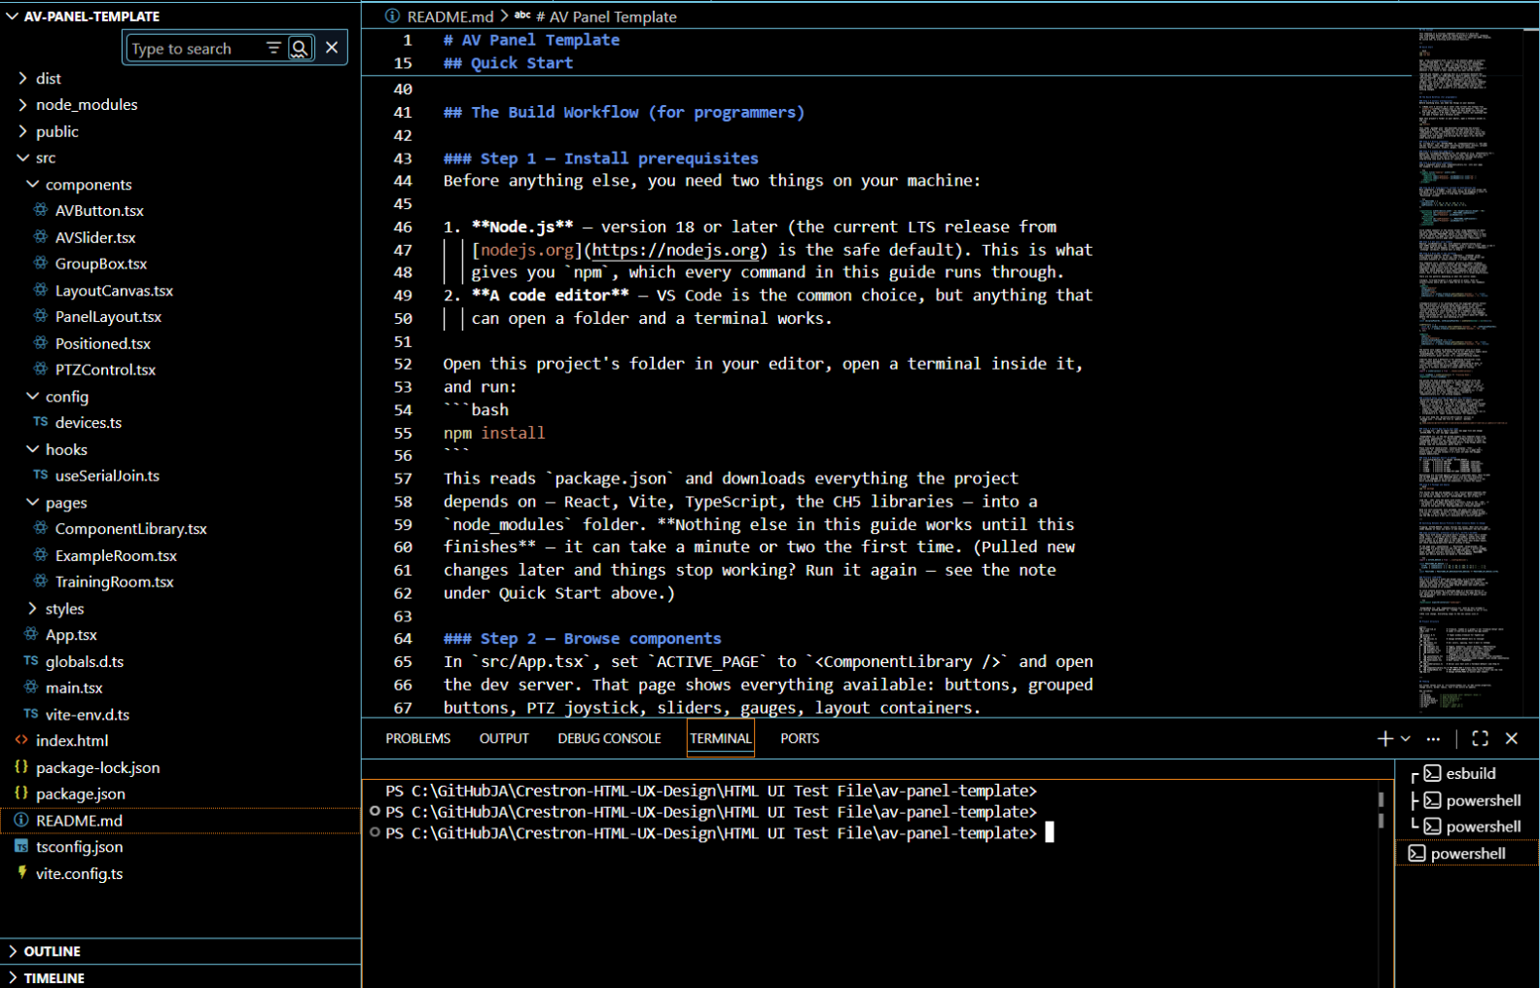

From there, we can take a look at the left pane under the src folder, which houses all of our components, pages, and configurations. Under components, you'll find AVButtons, Sliders, Gauges, Group Boxes, and more — each with logic that ties them to a specific join number, subscribed state, and size. Next is the config page, which houses different Crestron resolutions to build for, such as 1080 or 770. The real magic happens in the pages subfolder, where we first see the components library put to use.
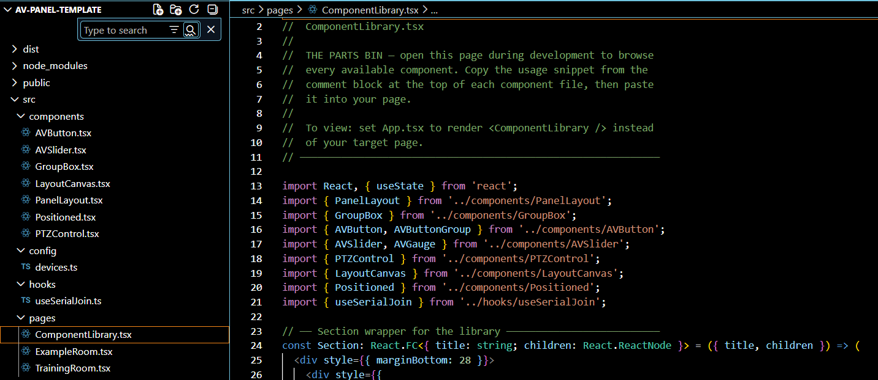

The components library houses all of our buttons, sliders, gauges and more in a visual "parts bin," which I will cover how to view later.
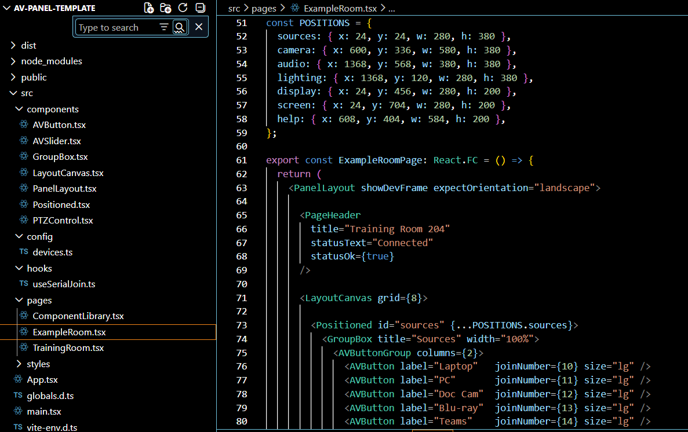

After the components bin we have our example room page. This page is intended to be copied and duplicated in the code to then add as many as required for the project. As you can see in the photo examples, I have duplicated the example page to create the Training Room page, which I then edited with my desired buttons and layout for my project. Before going over how to view the pages, I want to cover the App.tsx file first, which has a feature to change the active page you are viewing.
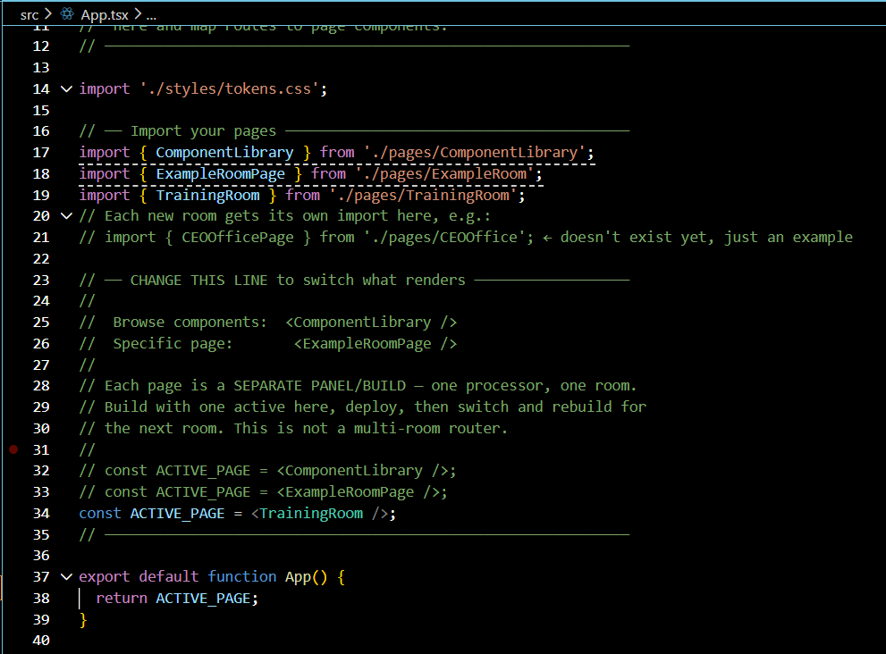

To switch views of your active page, comment out the current page that is active then uncomment out the desired page. Each added page to the project will have an “export” line in the page itself and a corresponding “import” line in the App.tsx file as shown in the above photo.
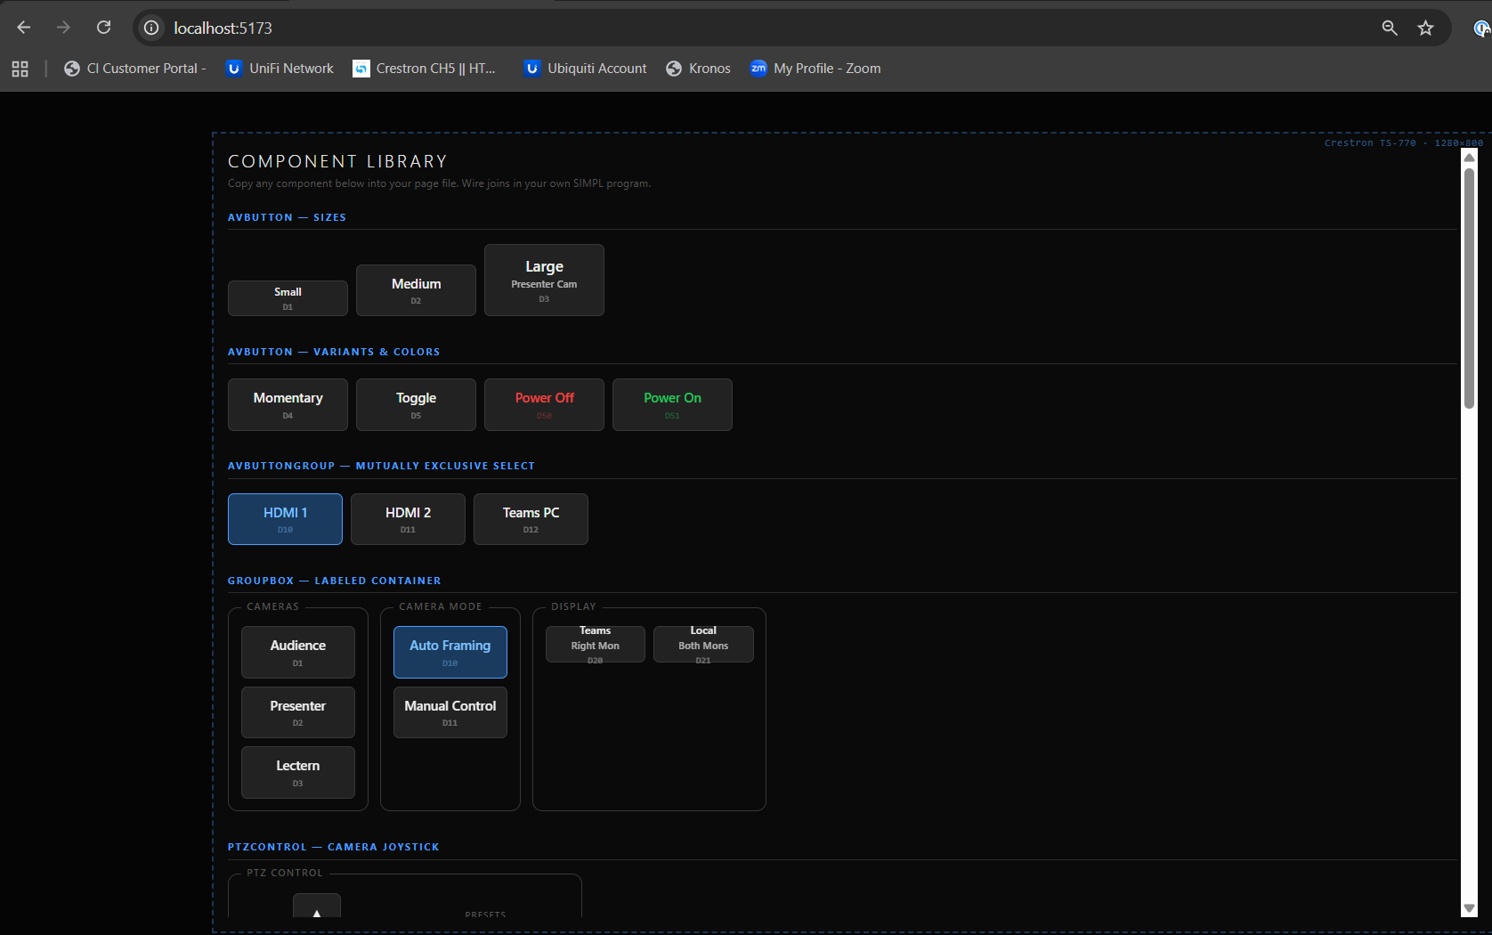
To view your active page, open a terminal window in the project folder and type npm run dev. This will start a local dev server and provide a link (typically http://localhost:5173) that you can open in your browser to see your active page. If I make the components library the active page in App.tsx, we will see all our components for this UI that we can use in our other pages.

Next is a drag-and-drop method built specifically for this UI app design. On your new page, you'll find an "Edit Layout" button that only shows in dev mode. Select "Edit Layout," then move the buttons and groups to the desired locations. Next, click "Copy Positions" — this copies the layout formatting, which you'll then paste into the POSITIONS object in your specific page to save the new layout.

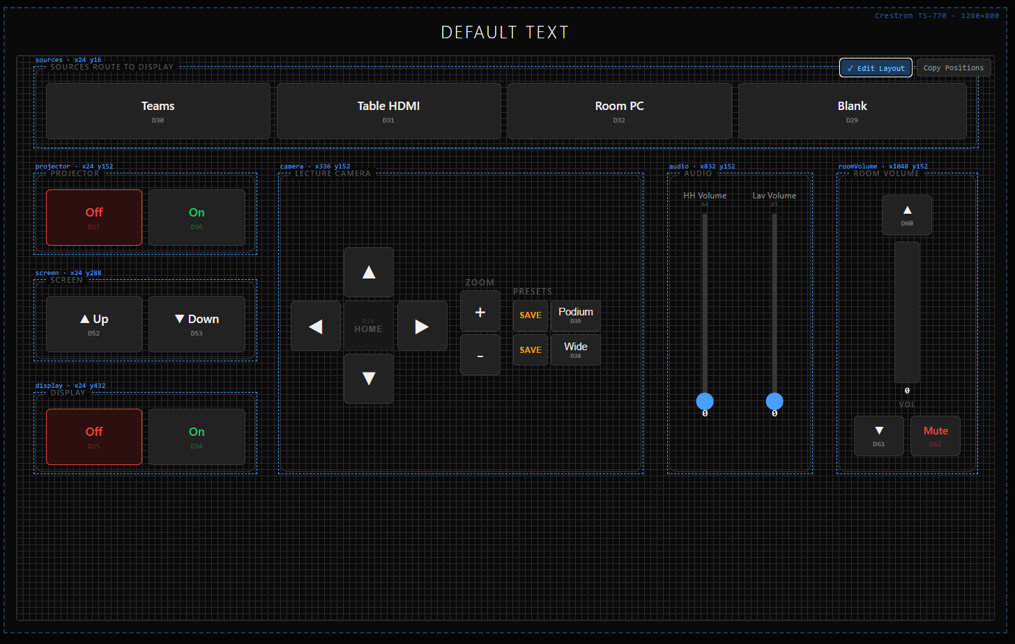

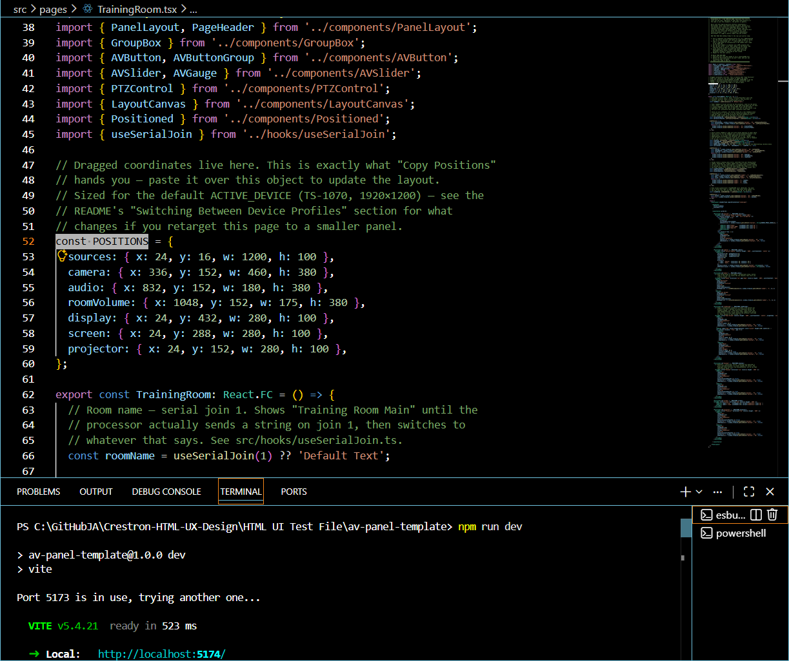

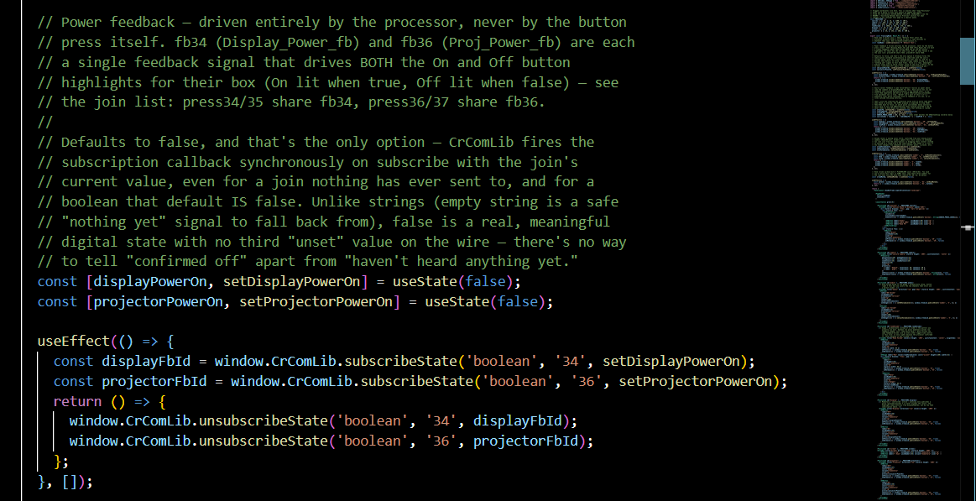
Regarding active feedback, let’s take a closer look at the display and projector on and off buttons. In the photo on the previous page, we see the off buttons showing as highlighted, yet this UI isn’t tied to an active processor. That’s because CrComLib delivers a join’s current value the moment you subscribe to it, even before the processor has sent anything. For a boolean join, that default is false, and there’s no separate “unset” state the way there is for a serial join, which defaults to an empty string — so “confirmed off” and “nothing received yet” look identical, which is why Off shows lit by default until the processor says otherwise. For the source routing buttons, we have individual feedback for each button as well, with one “Blank” button (tied to the Signal_Route_Clear join) to clear the route.

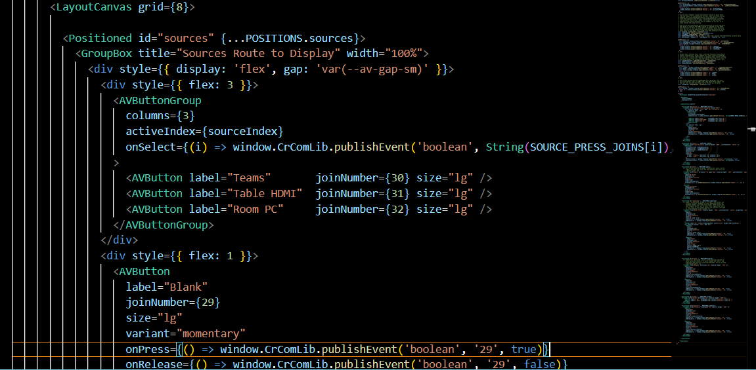

When the project is completed, it will still need to be compiled to a .ch5z file to then be loaded to a touch panel. In my React app, I have a built-in way for this to compile automatically to a .ch5z, which is explained in-depth in the README. Basically, if all dependencies are installed from Step 1, then running npm run package in the terminal window will output a compiled .ch5z file ready to be loaded to your touch panel. If you have a project with varying sizes of touch panels, then a recompile will need to be done for each panel type after changing ACTIVE_DEVICE in the devices.ts file (inside the config folder).

